**HOW TO SET UP RASPBERRY PI’S**

**Equipment:**

* Raspberry Pi 4
* Raspberry Pi 4 power supply
* SD cards containing micro SD card
* HDMI connector
* Mouse
* Keyboard
* WIFI connection
* Your Own Laptop or PC with SD card port

Set up your SD Cards

If you have an SD card that doesn’t have the Raspbian operating system on it yet, or if you want to reset your Raspberry Pi, you can easily install Raspbian yourself. To do so, you need a computer that has an SD card port — most laptop and desktop computers have one.

The Raspbian operating system via the Raspberry Pi Imager

Using the Raspberry Pi Imager is the easiest way to install Raspbian on your SD card.

Download and launch the Raspberry Pi Imager

* Visit the [Raspberry Pi downloads page](https://www.raspberrypi.org/downloads)

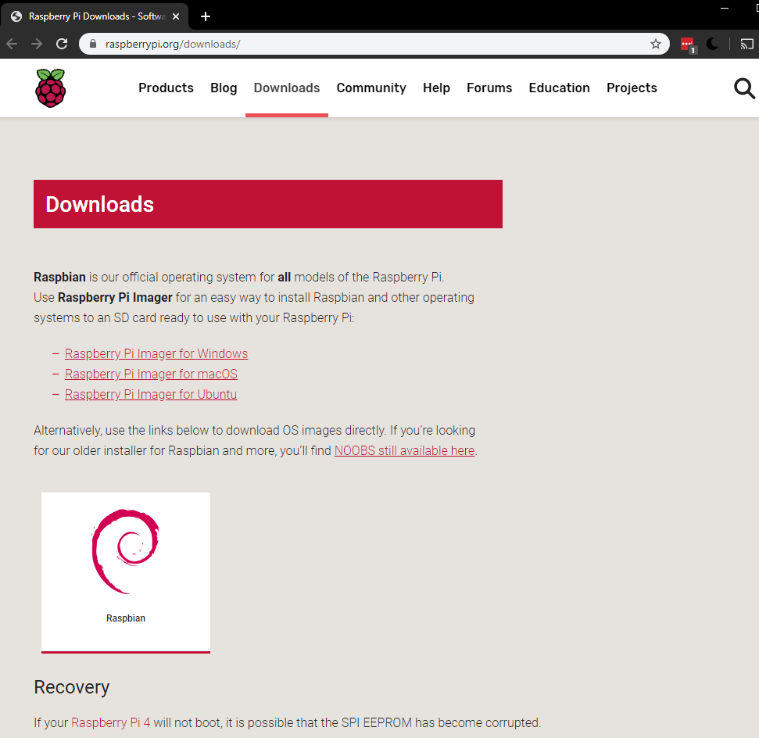

* Click on the link for the Raspberry Pi Imager that matches your operating system on the computer you are currently using

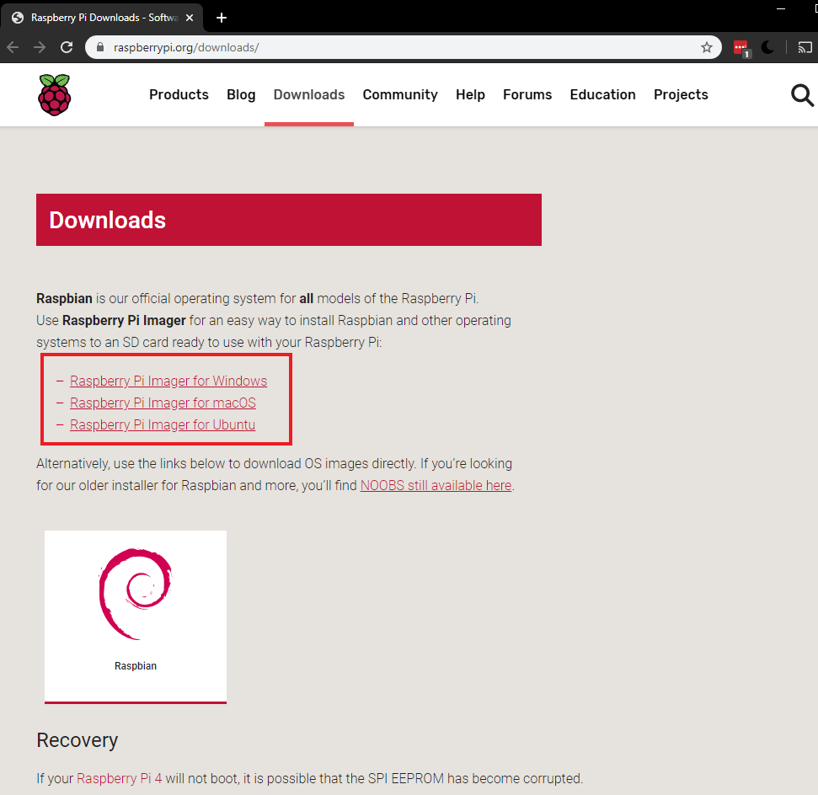

* When the download finishes, click it to launch the installer

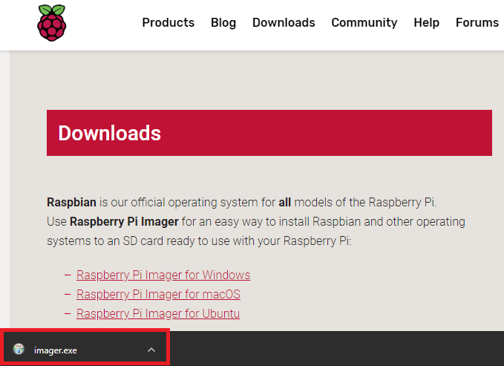

#### Using the Raspberry Pi Imager

Anything that’s stored on the SD card will be overwritten during formatting. If your SD card currently has any files on it, e.g. from an older version of Raspbian, you may wish to back up these files first to prevent you from permanently losing them.

When you launch the installer, your operating system may try to block you from running it. For example, on Windows I recieve the following message:

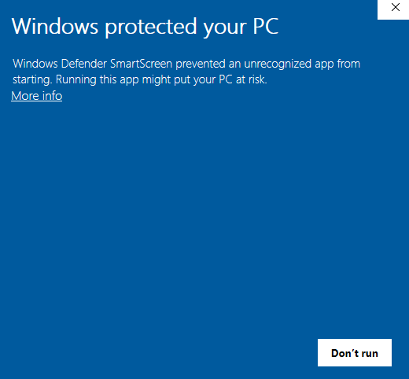

* If this pops up, click on More info and then Run anyway
* Follow the instructions to install and run the Raspberry Pi Imager
* Insert your SD card into the computer or laptop SD card slot
* In the Raspberry Pi Imager, select the OS that you want to install and the SD card you would like to install it on

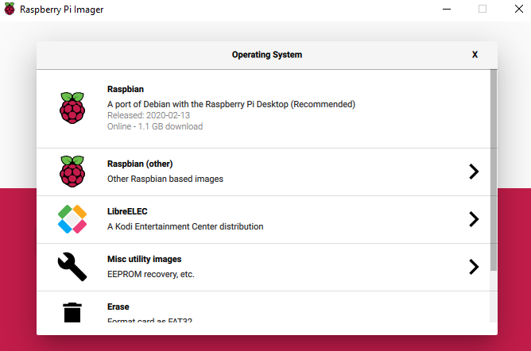

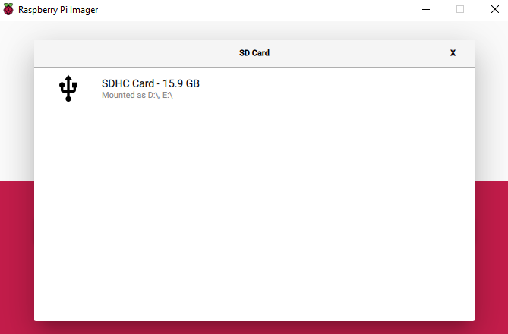

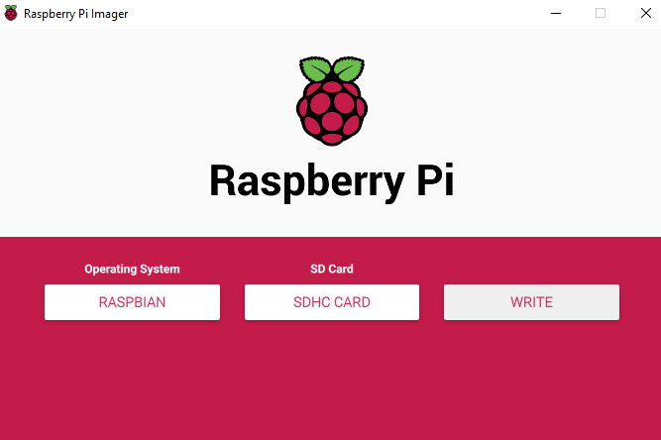

* Then simply click the WRITE button
* If you get a error that cant connect to server just repress write
* Wait for the Raspberry Pi Imager to finish writing
* Once you get the following message, you can eject your SD card

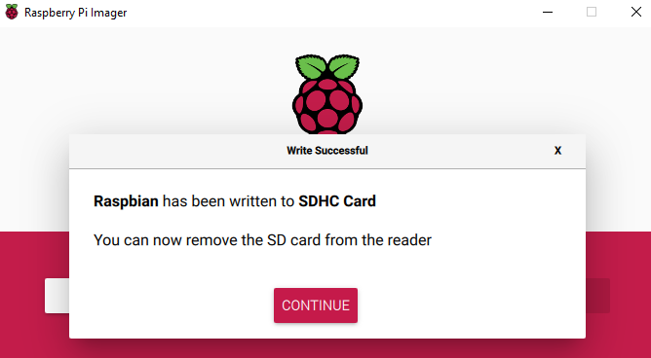

## Connect your Raspberry Pi

Now get everything connected to your Raspberry Pi. It’s important to do this in the right order, so that all your components are safe.

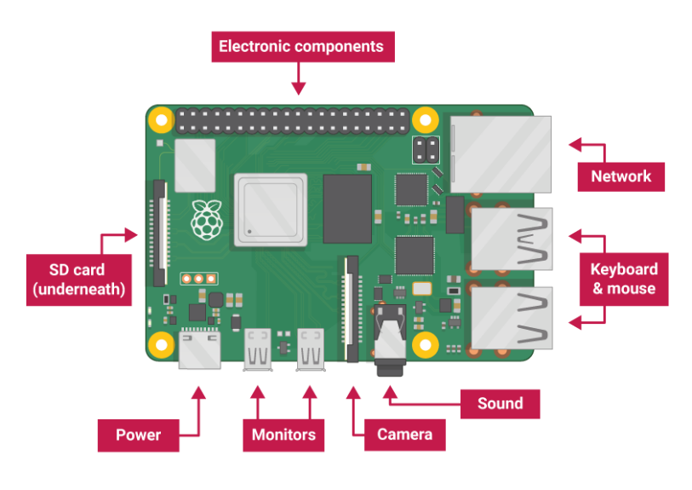

* Insert the SD card you’ve set up with Raspbian (via NOOBS) into the microSD card slot on the underside of your Raspberry Pi.

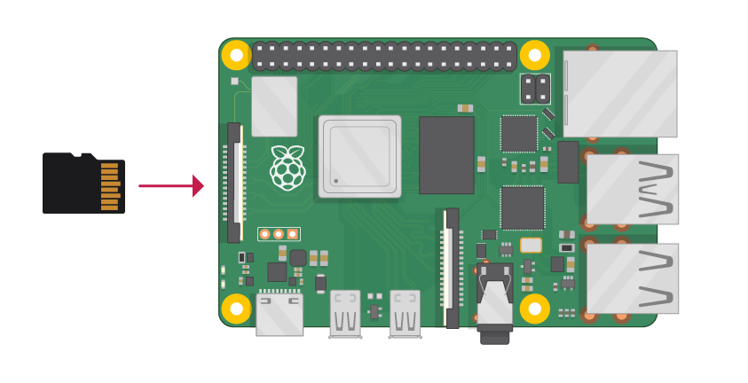

**Note:** Many microSD cards come inside a larger adapter — you can slide the smaller card out using the lip at the bottom.

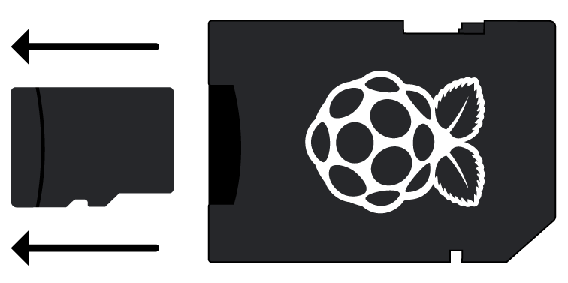

* Find the USB connector end of your mouse’s cable, and connect the mouse to a USB port on Raspberry Pi (it doesn’t matter which port you use).

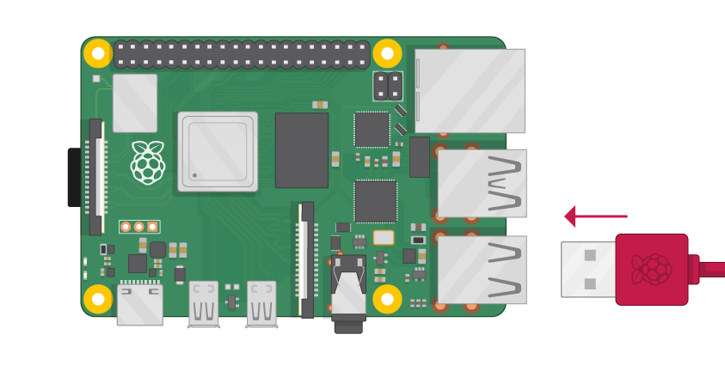

* Connect the keyboard in the same way.

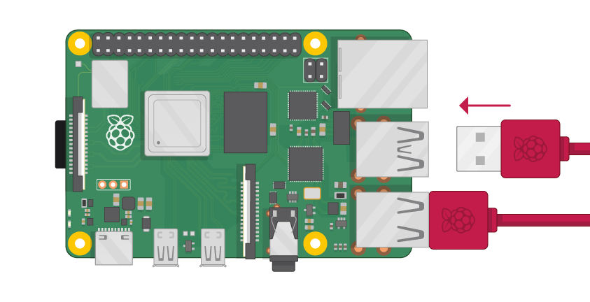

* Make sure your screen is plugged into a wall socket and switched on.
* Look at the HDMI port(s) on the Raspberry Pi — notice that they have a flat side on top.
* Use a cable to connect the screen to Raspberry Pi’s HDMI port — use an adapter if necessary.

**Raspberry Pi 4**

Connect your screen to the first of Raspberry Pi 4’s HDMI ports, labelled **HDMI0**.

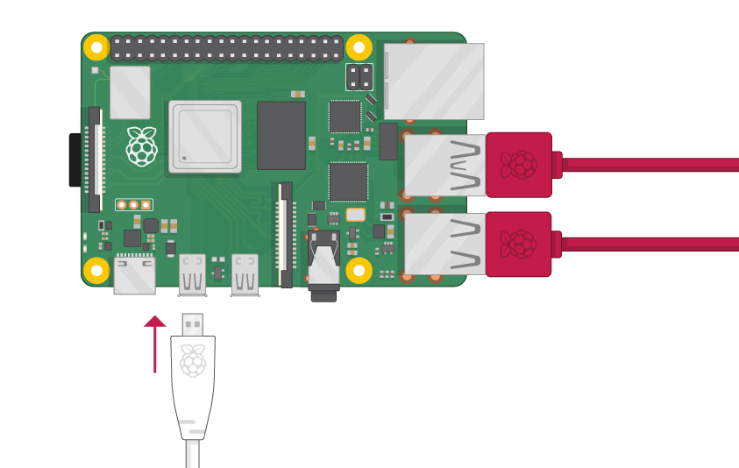

You can connect an optional second screen in the same way.

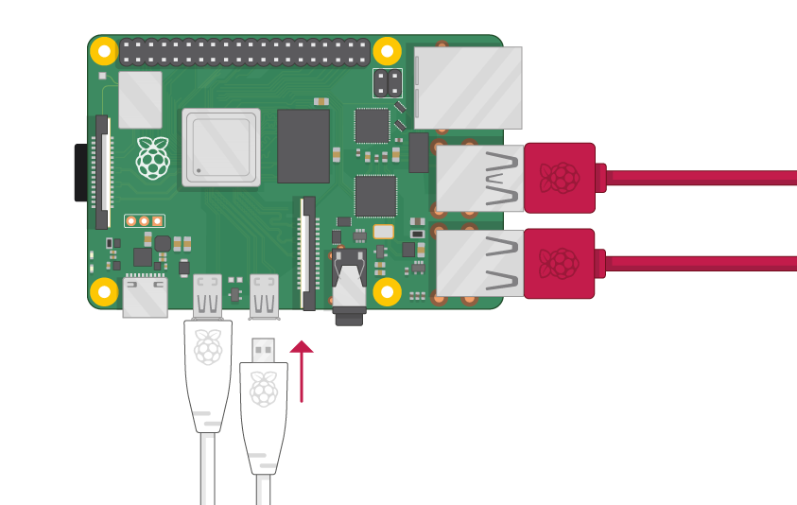

**Raspberry Pi 1, 2, 3**

Connect your screen to the single HDMI port.

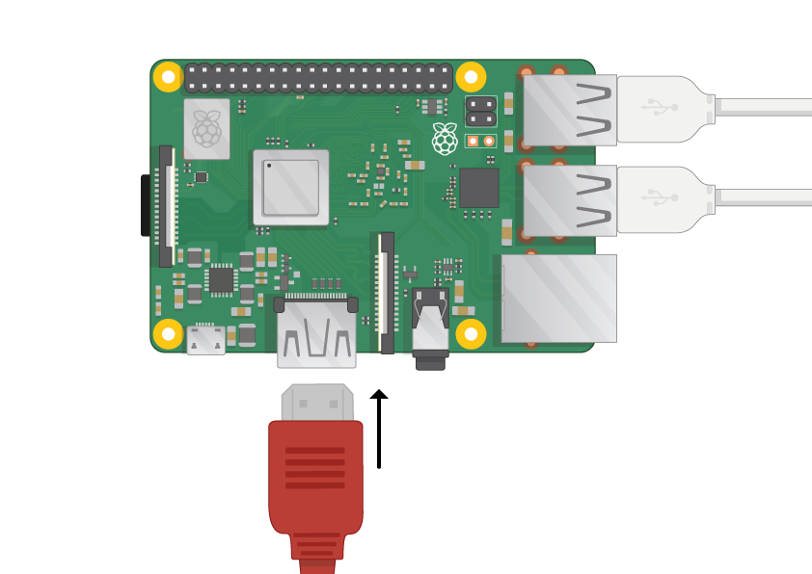

**Note:** nothing will display on the screen, because your Raspberry Pi is not running yet.

* If you want to connect your Raspberry Pi to the internet via Ethernet, use an Ethernet cable to connect the Ethernet port on Raspberry Pi to an Ethernet socket on the wall or on your internet router. You don’t need to do this if you want to use wireless connectivity, or if you don’t want to connect to the internet.
* Alternatively you can connect to the internet via WIFI in later steps (after bootup this step will be done).

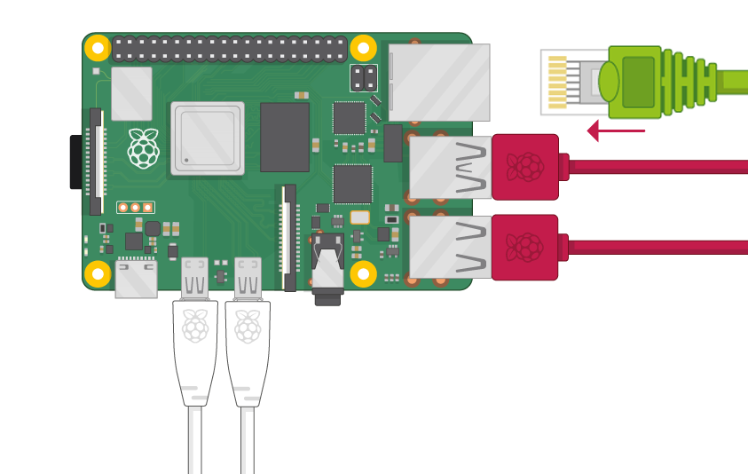

* If the screen you are using has speakers, sound will play through those. Alternatively, connect headphones or speakers to the audio port if you prefer.

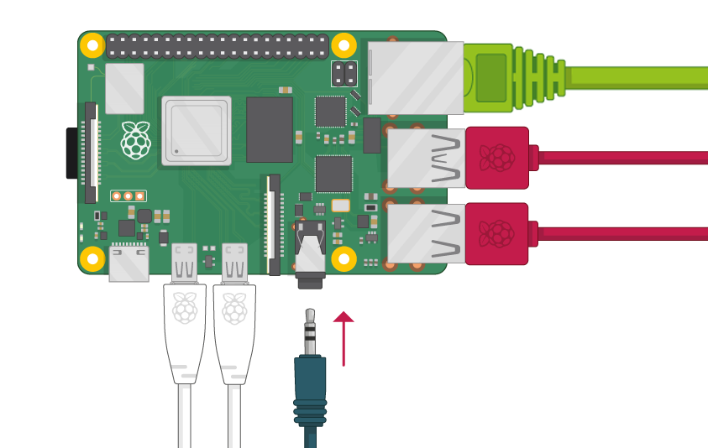

## Start up your Raspberry Pi

Your Raspberry Pi doesn’t have a power switch: as soon as you connect it to a power outlet, it will turn on.

* Plug the USB power supply into a socket and connect it to your Raspberry Pi’s power port.

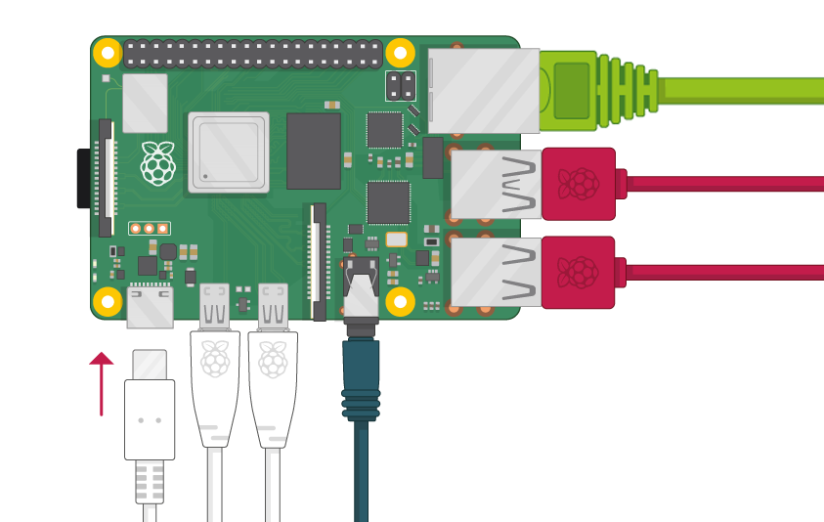

You should see a red LED light up on the Raspberry Pi, which indicates that Raspberry Pi is connected to power. As it starts up (this is also called **booting**), you will see raspberries appear in the top left-hand corner of your screen.

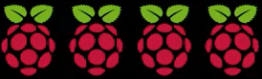

## Finish the setup

When you start your Raspberry Pi for the first time, the **Welcome to Raspberry Pi** application will pop up and guide you through the initial setup.



* Click **Next** to start the setup.
* Set your **Country**, **Language**, and **Timezone**, then click **Next** again.

pi wizard country

* Enter a new password for your Raspberry Pi and click **Next**.

pi wizard password

* Connect to your WiFi network by selecting its name, entering the password, and clicking **Next**.

pi wizard wifi

**Note:** if your Raspberry Pi model doesn’t have wireless connectivity, you won’t see this screen.

* Click **Next** let the wizard check for updates to Raspbian and install them (this might take a little while).

pi wizard updating

* Click **Done** or **Reboot** to finish the setup.

**Note:** you will only need to reboot if that’s necessary to complete an update.

pi wizard complete

## Set Up Databases

Once the setup is finished the screen should like as below:

* Click **the applications menu (the Raspberry icon in the top left corner).**

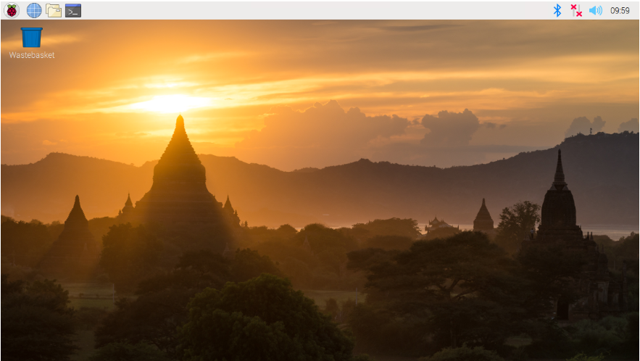

* **Continue with the Quick Set up and install appropriate packages.**